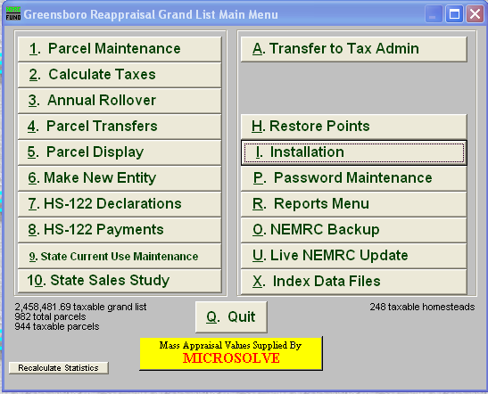

Main Menu option 10 State Sales when files become available. Generally this will be done in your Working Grand List to start and will be finished in your As Billed Grand List.

- Click ‘Get Sales Study file from State’ button to download your sales study file.
  - If your town is doing a Partial, Rolling, or Full reappraisal the file will contain 3 yrs of sales
  - Typical (non reappraisal) sales study files will only have 1 yr of sales to be reviewed

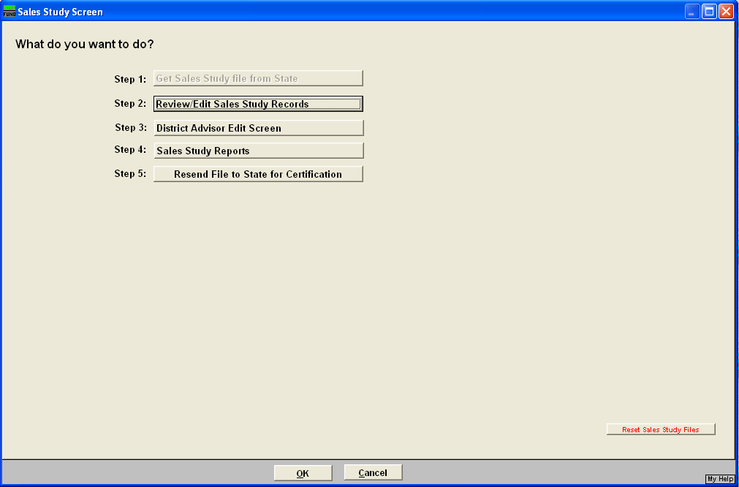
2. Users will select parcels in the download Sales Study file to review and edit. See page 3 for screen details.

3. District Advisor Edit screen. This option may be filled out by the Listers but must be sent back to the State PVR by your DA. The Sales Study file should not be sent back to PVR until your District Advisor has reviewed all questions on these screens as seen on page 2.

4. Print various reports to keep for your physical records.

5. Send file back to PVR.
- Contact your District Advisor for Step 5.
- Upload will only be permitted when authorized by DA or other PVR personnel.
- Once the file has been sent to PVR then the data cannot be edited by the listers any further.

NOTE: Files can only be reset and downloaded a 2nd time with the assistance from PVR or IT staff.

- District Advisor Sales Study Checklist screens. Once this data has been entered click on the ‘Save and Return to Main Menu’ button to save your changes. Some of the information will copied from one year to the next.
- The District Advisors or the Listers can print out a copy of the District Advisor Checklist by clicking on the button labeled ‘Print DAEQ Study Checklist’.

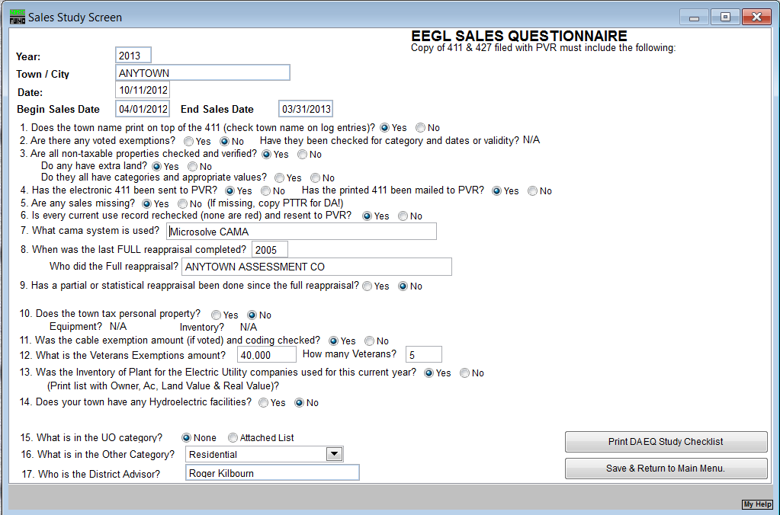

2. Users will select parcels in the download Sales Study file to review and edit.

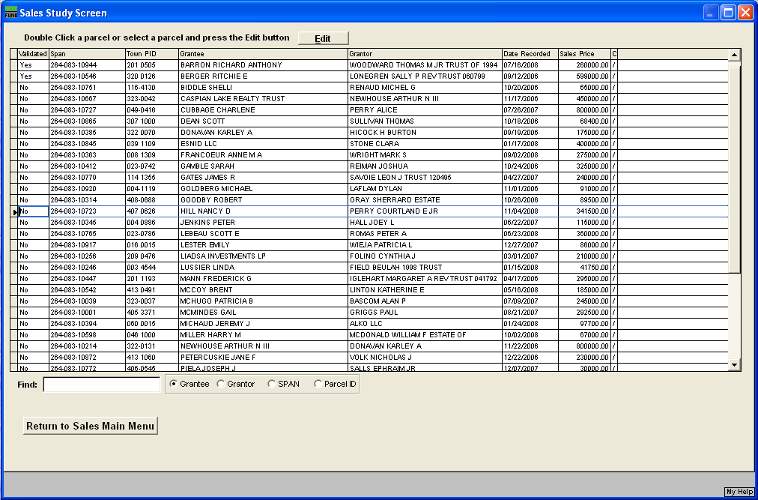
Editing – Option #2 users will select a parcel to review and edit if necessary. Users can search for records by ‘Span #, Grantor, Grantee, or Parcel ID’.
Column Headers on this screen:
Validate –Every individual record must be reviewed by the Listers (ask your DA about validating each record) The DA may wish to validate each record when they review the data.
All parcels must be validated before a file can be uploaded to PVR.

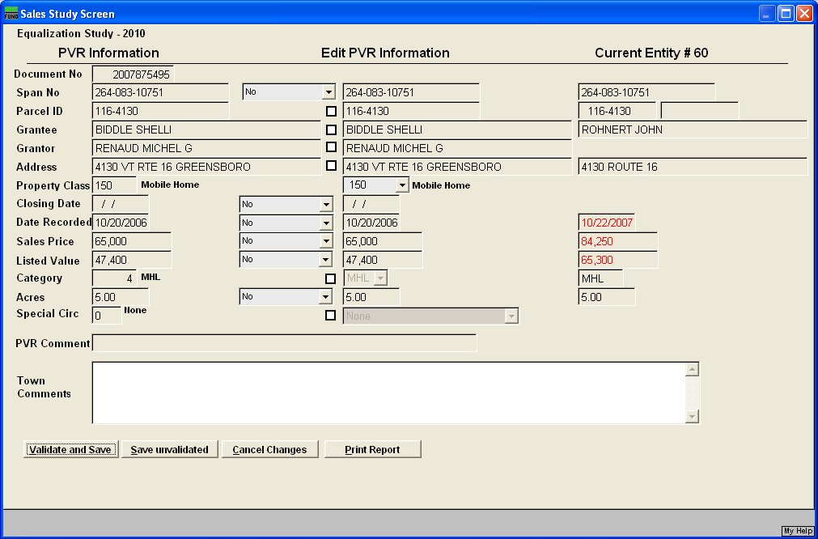
Editing – individual records.
The data at the top and in left column is “read only” data which is provided from the download file.
To edit data in the middle column, place a check in the box to the left of the field that is incorrect or make the appropriate selection using the dropdown box. This will allow you to make your corrections in the field on the right. If you select ‘Other’ as a drop down choice you will need to enter a reason for the change in the Town Comments field.
The column on the right will display the parcel information from the appropriate as billed entity for this sale. If you are doing a reappraisal then this column will be the reappraisal Grand List.
Fields highlighted in red identify data that is in your grand list that do not match the PVR information downloaded.
Special Circumstances – This is a numeric field to allow for user input if a sale is determined to be not “arm’s length”. PVR special circumstance codes 1-22 are provided to identify the circumstances of the sale. By default this box will typically be “ZERO” or presumed to be a valid sale. Any sale sent back to PVR that has a special circumstance code greater than ZERO – with the exception of code 22- which indicates a resale – will not be included in the sales study. Provide an explanation in the comments box explaining the circumstances of the sale if excluded from consideration
Validate - Once a record is edited or reviewed, select the ‘Validate and Save’ button and repeat this process until all records are validated.

- Check the following prior to meeting with your District Advisor:
- Is parcel & Span number correct?
- Does the name and location match the Grand List?
- Is the correct property class and category entered?
- Does the closing date, sale date, and sale price match the PTTR?
- Does the listed value, category and acreage match the Grand List?
- Is the parcel an “Active” or “Inactive” file? If “Inactive make sure it has been combined with an “Active” parcel.

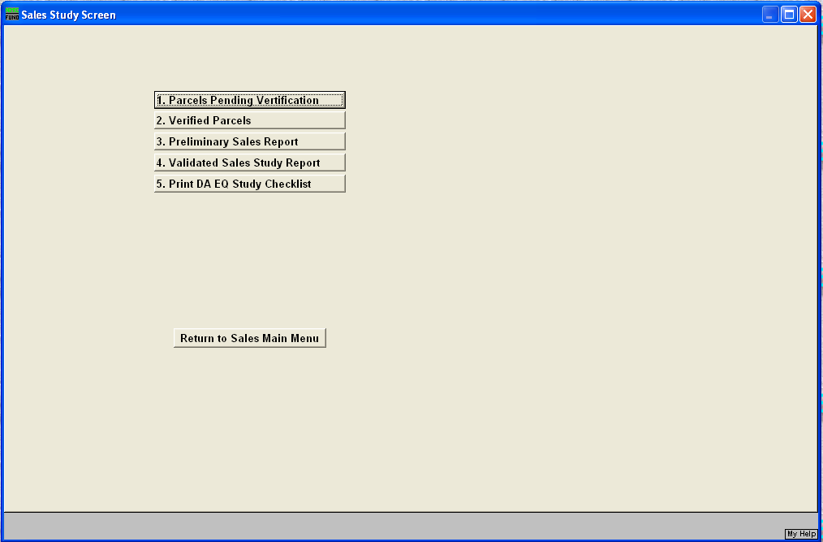
Sales Study Reports Menu –
1. Parcels Pending Validation –Lists all the parcels that still need to be reviewed and validated.
2. Validated Parcels Report – Lists all the parcels that have been reviewed and validated by the Listers.
3. Preliminary Sales Report – Reports the sales data as originally downloaded from PVR.
4. Validated Sales Report – This report can only be run when all parcels in your sales study file have been validated. The report will show 2 sections for each parcel in the sales study file.
The section labeled ‘PVR’ on the left side lists the original data.
The section below labeled ‘EDT’ on the left side shows lists only those fields that have been edited. See the example below.
5. DA Equalization Study checklist report – This is the D/A check list report. It can also be printed from the D/A section of the program.

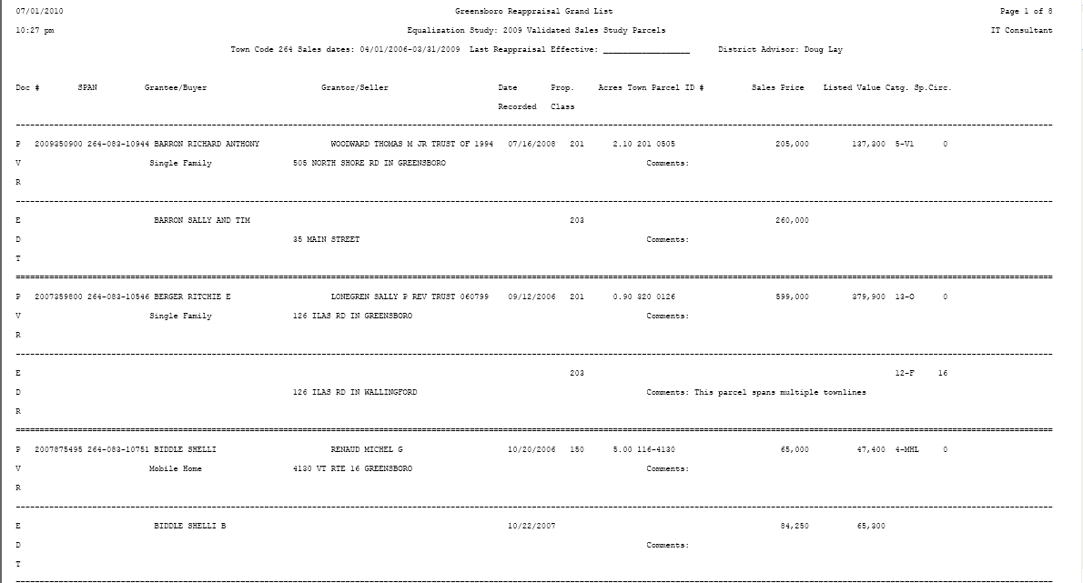
Original Sales data as downloaded from PVR

Data edited by Listers. Only data edited appears in this section.

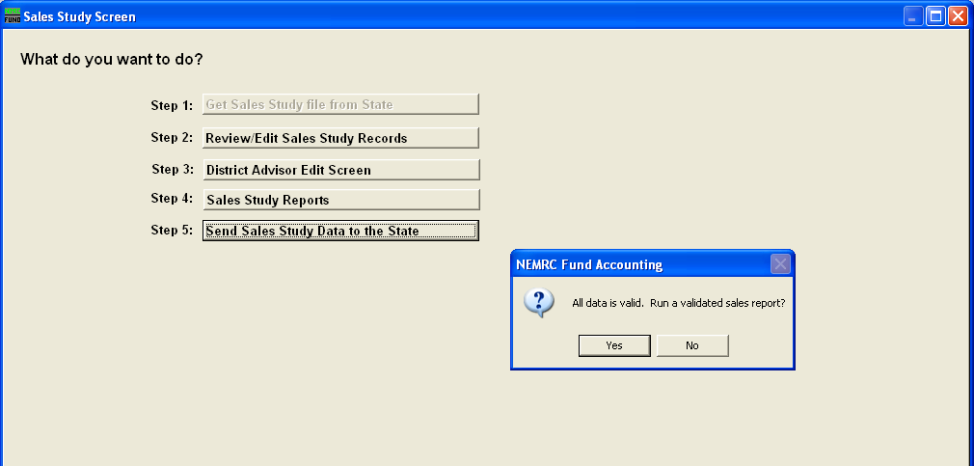
Sending Sales Study Data to the State – The District Advisor will select this option when all of your sales have been validated and are ready to be sent to PVR. The program will prompt you to print a ‘Validated Sales Report’ for your records.

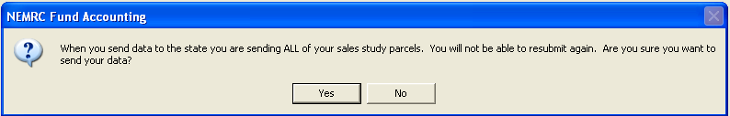
The prompt will appear on the screen confirming that the file is ready to be sent to PVR

Next the program will prompt you with a password before the file can be transferred. This password will be provided by your District Advisor.
IF you do not have the password simply leave this field blank and press the ‘Continue’ button and the program will ask you to try again when you do have the password.
Once the file is sent to PVR, you cannot edit the sales study data further. You will still be able to print reports.
